CA2 Individual Report
Name | Royston Koh
Student Id | P2509316
Class | Example: DIT/FT/2A/06
Github Repository URL | https://github.com/RoystonKoh/st0525-ca2-restaurant-ordering-system
Github Account ID | RoystonKoh

For each criterion, provide links to pull requests/commits/files that demonstrate the completion of the requirement. Replace each “?” with your Self Rating.
For Self Rating, you may rate yourself accordingly if you feel that you:
- Have little or no understanding. and did not attempt the requirement.
- Have limited understanding to demonstrate competency for the criterion.
- Have basic understanding and only able to replicate examples from tutorials/practicals.
- Have adequate understanding and can extend from what you have learned to fulfil specifications.
- Have solid understanding in the specific criterion, able work on the requirement without much references.
- Have excellent understanding and implemented the requirement according to latest industry guidelines, best practices and documentations.

Important
- You are required to provide for each criterion:
  - Documentation and description of the work done.
  - One to three of your best implementations with URL link to respective repository files/commits/pull requests.
  - You should also provide screenshots where relevant.
- You are to ensure the hyperlink in this document works. Failure to do so will result in a 50% deduction of marks.

No. | Criterion | Describe What Was Done | Self Rating
1 | Database Design & ORM Modeling | - Provide a clear screenshot of your ERD. ERD should be diagrammed on Lucid Chart and Screenshot should be based on the corresponding image exported.  - What are the new models defined in the schema file?  - Provide link to schema file  - What are additional assumptions you made and reasons for your design decision(s)? | 3/5
2 | Cart Management feature Implementation | - What are the backend functions (eg ORM functions, model, controller, route) & the front-end changes? (eg html, js)?  - Provide links to relevant files/commits/pull requests of the above  - Any screenshots of how you test for errors and success conditions? | 3/5
3 | Checkout feature Implementation | - What are the backend functions (eg ORM functions, model, controller, route) & the front-end changes? (eg html, js)?  - Provide links to relevant files/commits/pull requests of the above  - Any screenshots of how you test for errors and different conditions/scenarios/business rules?  - How flexible or extensible is your implementation of the feature? | 3/5
4 | Transaction Management | - What is the stored procedure to manage transactions for place order?  - Provide screenshots of how you test that it successfully handles different conditions.  - What are the backend functions (eg ORM functions, model, controller, route) & the front-end changes (eg html, js)?  - Provide links to relevant files/commits/pull requests of the above | 3/5
5 | Indexing | For each of your proposed queries (between 3 to 6)  - State what is the query proposed  - State what type of index is used and what is the SQL statement used to create the index  - Provide proof of improved query performance and explain the key reason(s) for the improvement | 3/5
9 | Report Quality | Based on quality of documentation for above criteria.  No inputs required here. | 3/5
10 | Demonstration & Interview | Based on assessment during demonstration & interview.  No inputs required here. | -

1. Database Design and ORM Modelling
The solution keeps the five original restaurant tables (member, member_role, product, sale_order, and sale_order_item) structurally unchanged. It adds the required Cart and CartItem entities, two pricing-policy entities (PricingRule and OrderPricing), and two optional customer-voucher entities (Voucher and CartVoucher). This design follows the CA2 instruction to use ORM models for cart management and supports data-driven product and delivery/service incentives without modifying an original restaurant table.
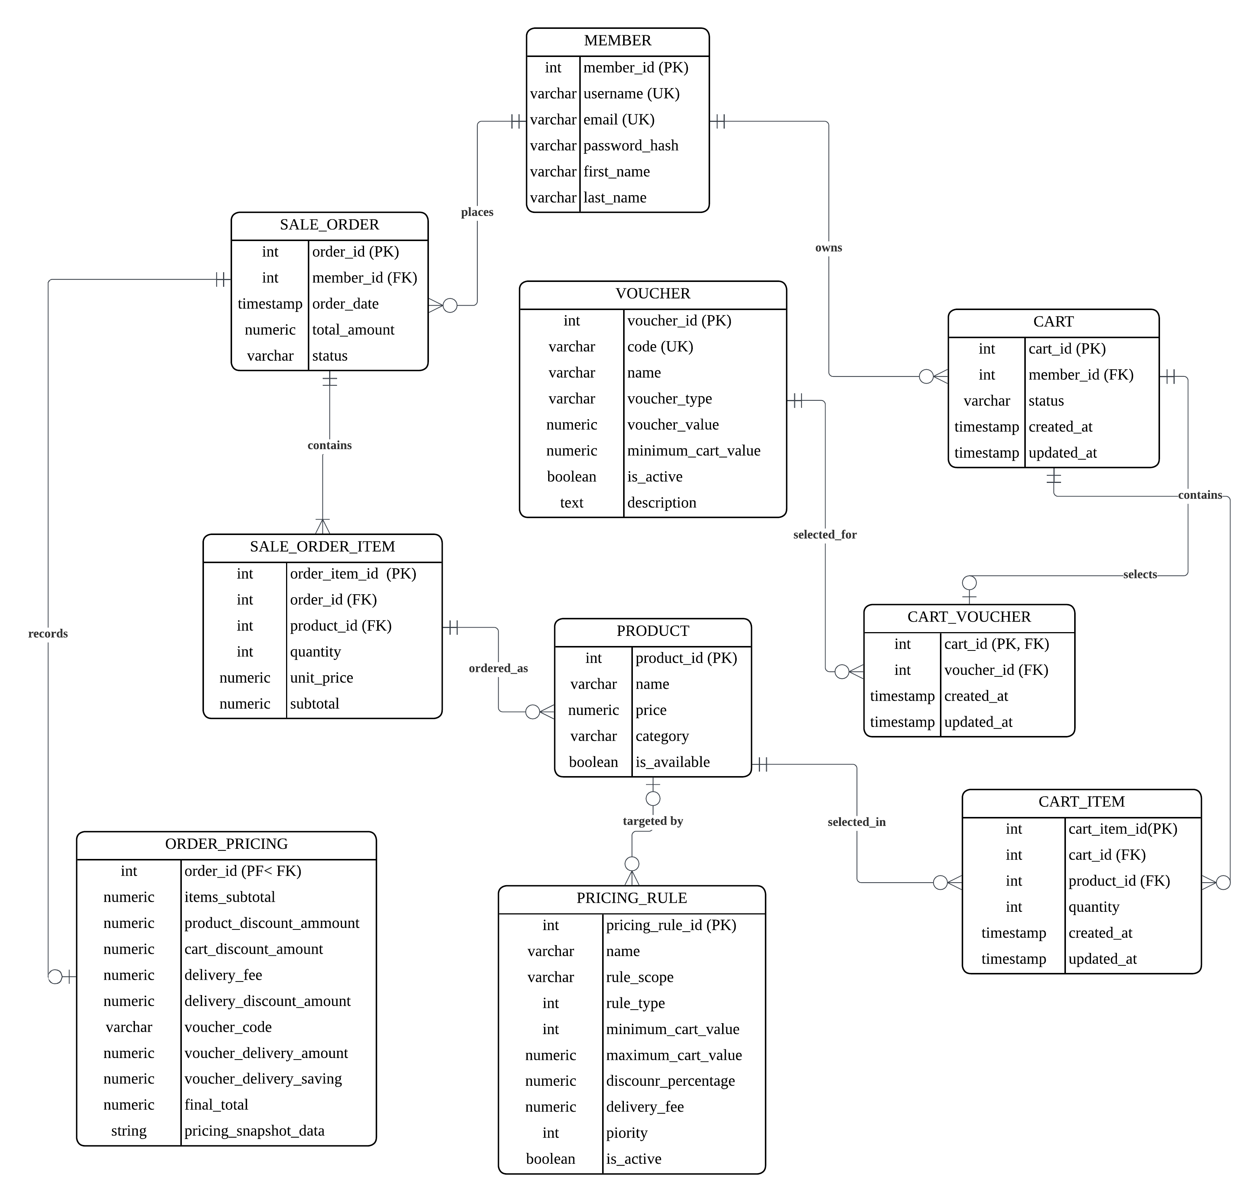
Final CA2 Entity Relationship Diagram
New entity | Key attributes and constraints | Relationship and rationale
cart | cart_id, member_id, status, timestamps; partial unique index ensures one active cart per member. | A member owns carts. Cart data is mutable and independent from historical orders.
cart_item | cart_item_id, cart_id, product_id, positive quantity; unique (cart_id, product_id). | A cart contains product lines. The uniqueness rule means adding the same product increments quantity through Prisma upsert rather than duplicating rows.
pricing_rule | Scope, type, optional product target, quantity/cart thresholds, discount percentage, delivery fee, priority, active state. | Represents configurable product-quantity, cart-value, and delivery-tier policies. New tiers can be added in data by an administrator.
voucher | Unique code, name, type (PERCENT, FIXED, or FREE_DELIVERY), value, threshold, active state, description. | Holds optional reusable customer offers in a new table without changing the restaurant tables.
cart_voucher | cart_id is the primary key; voucher_id is a foreign key. | Gives each active cart zero or one selected voucher, which a customer can select or clear.
order_pricing | One order_id, item subtotal, product/cart discounts, voucher code/savings, delivery fee/savings, final total, JSON pricing snapshot. | Stores the immutable calculated result for a newly created order without altering the original sale_order table.

The Prisma schema maps all original and new relations using @map and @@map. Cart operations use the Prisma methods taught in the ORM practicals: findFirst, create, upsert, update, and delete. The customer cart summary is calculated on the back end after the ORM query, not trusted from browser input.
2. Cart Management Feature Implementation
The end-to-end customer flow starts at /cart/create, which presents restaurant products and calls POST /cart/items. The protected Cart model obtains or creates the member’s active cart, validates product identity and a positive whole-number quantity, then uses Prisma upsert to create or increment one cart item. The member retrieves the complete cart at /cart/retrieve/all, changes a single line through PATCH /cart/items/:cartItemId, and deletes one line through DELETE /cart/items/:cartItemId. The API returns a fresh server-side summary after each change.
Layer | Implementation | CA2 purpose
Customer pages | views/products.html, views/cart.html, views/checkout.html | Provides the required add, retrieve, update, delete, and end-to-end checkout interactions.
Protected routes | routes/cart.js | Exposes create/retrieve pages and authenticated customer API endpoints.
Controller validation | controllers/cartController.js | Rejects invalid IDs and non-integer/negative quantities before database operations.
Prisma model | models/Cart.js | Enforces active-cart ownership and performs ORM CRUD.
Database constraints | Cart/cart-item foreign keys, positive quantity check, unique product per cart | Prevents invalid rows even if a request bypasses browser controls.

The cart accepts an unavailable product so that the required transaction behaviour can be demonstrated. Availability is shown clearly in the cart. At checkout, available items are processed and removed; unavailable items remain in the active cart, rather than causing prior work to be lost. This matches the appendix scenarios in the CA2 brief.
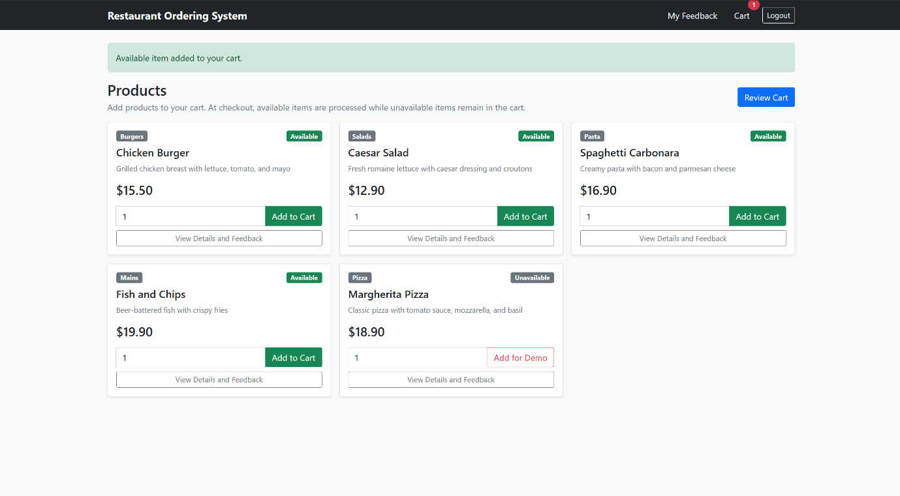
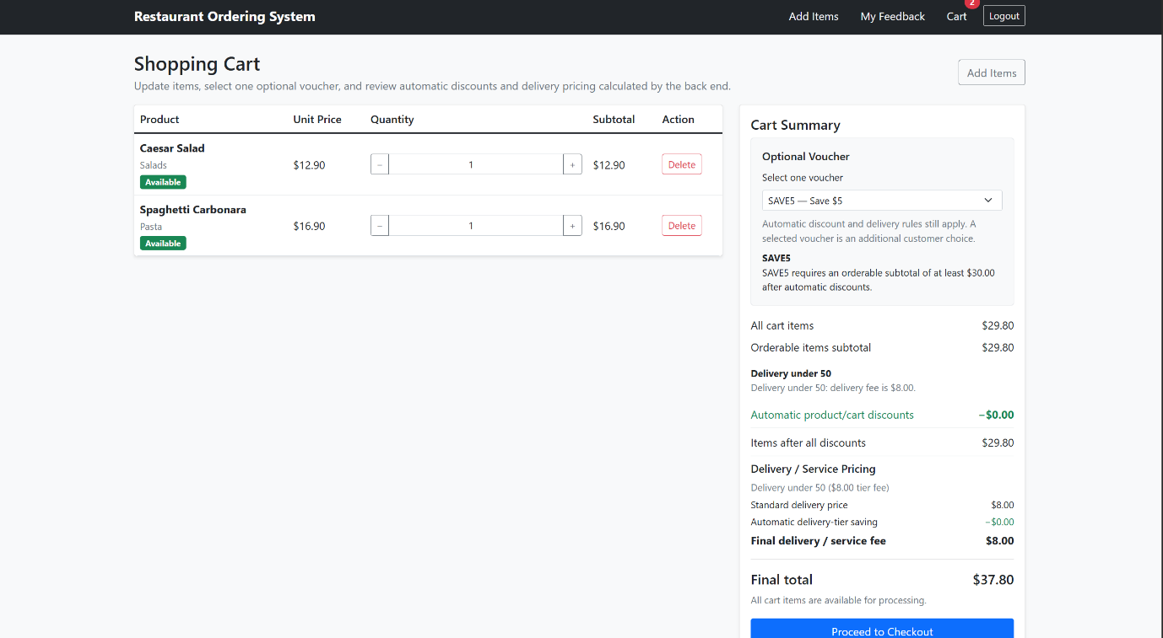
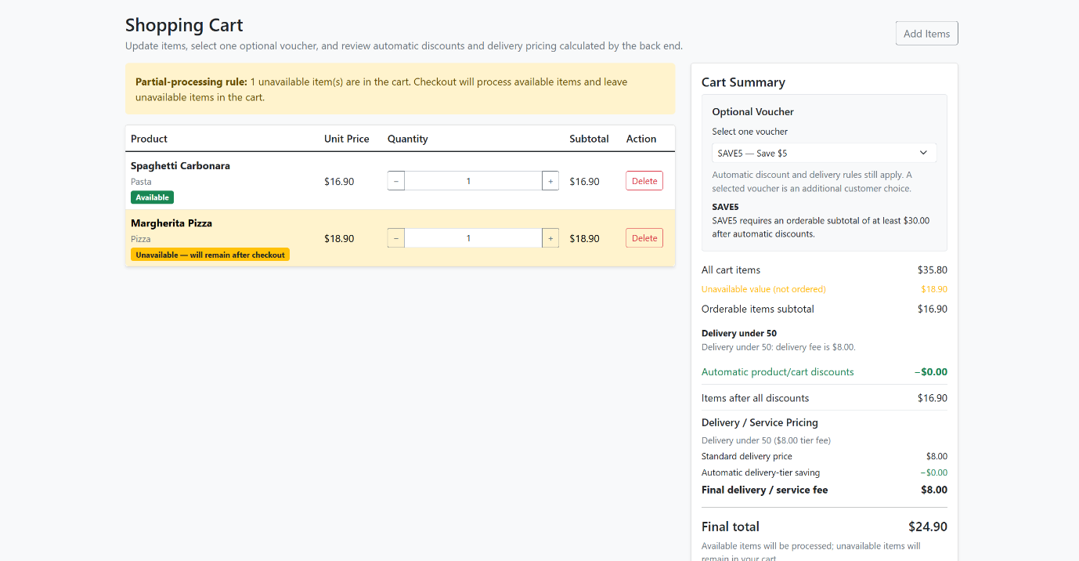

3. Checkout, Stackable Discounts, Delivery Pricing, and Administration
The checkout preview is calculated by PricingService on the server. It first evaluates all active automatic rules in pricing_rule: the highest eligible quantity tier per targeted product, then an eligible cart-value percentage discount against the post-product-discount subtotal, then the automatic delivery tier. The seeded tiers demonstrate $8 under $50, $5 from $50 to $99.99, and free delivery from $100. These automatic rules stack as required. After that sequence, the shopper may optionally select one active Voucher in the Cart dropdown. PERCENT and FIXED vouchers reduce the automatic discounted items total; FREE_DELIVERY waives the already-selected delivery-tier fee. A voucher cannot change the automatic delivery tier.
Requirement | Final implementation | Demonstration result
Product quantity discount | PRODUCT_QUANTITY_PERCENT rule with a product, minimum quantity, percentage, and priority. | Buy 3 of the target product applies 10%; Buy 5 applies the higher 15% tier.
Cart total discount | CART_VALUE_PERCENT rule with a cart threshold and percentage. | Spend $100 triggers 5% after the product quantity discount.
Stackable discounts | The pricing service adds product and cart-value discounts in sequence. | $130 orderable subtotal: $15.00 product discount plus $5.75 cart discount.
Delivery/service discount | DELIVERY_TIER rules use minimum/maximum cart value and a delivery fee. | The same high-value test selects the $0.00 free-delivery tier.
Optional PERCENT voucher | WELCOME10 is selected in the Cart dropdown after automatic rules. | $5.40 additional item saving on the Buy 3 scenario; the $5.00 automatic tier remains unchanged.
Optional FIXED voucher | SAVE5 is selected in the Cart dropdown after automatic rules. | $5.00 additional saving on the high-value stacked-rule scenario.
Optional FREE_DELIVERY voucher | FREEDELIVERY is selected after automatic delivery-tier evaluation. | The $5.00 tier charge is shown as a voucher delivery saving and final delivery becomes $0.00.
Flexibility/extensibility | Rules are rows, not hard-coded checkout conditions; voucher selection is stored separately per cart. | Administrator can add automatic product or delivery tiers; customers choose one optional active voucher without editing policy data.

The administrator management panel extends the existing restaurant dashboard. It is protected by the project’s existing ensureAdmin middleware. An administrator can view products and rules, create a product-quantity/cart-value/delivery-tier rule, edit it, and activate or deactivate it. This represents a sensible restaurant-management responsibility rather than exposing technical database controls to customers.
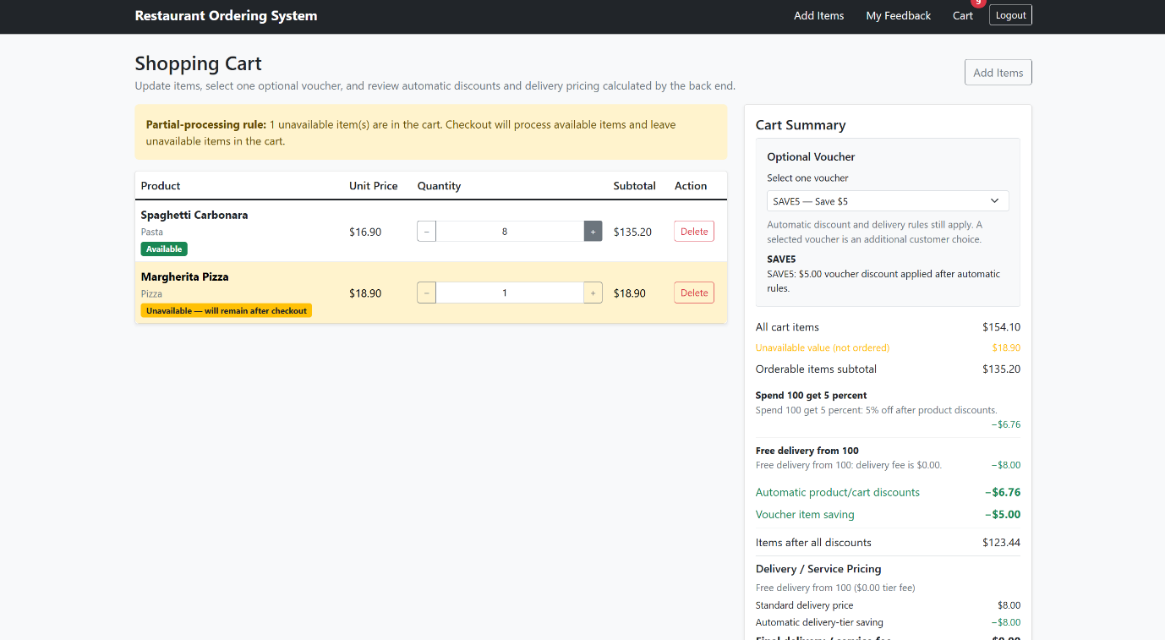
4. Transaction Management
The required procedure is named public.place_orders. The checkout controller calculates discount and delivery eligibility before calling it, then calls the procedure using the member ID. The procedure itself intentionally contains only cart-item and order processing logic, as required by the brief. It locks the active cart and loops through every cart item. When a product is available, it creates the order header if needed, creates an order item, and removes that cart item. When a product is unavailable, it increments a skipped count and leaves that item in the cart. It does not roll back items already processed merely because a later item is unavailable.

CA2 scenario | Expected database result | Verified outcome
Available item followed by unavailable item | One sale order and one sale order item exist; available cart item is deleted; unavailable item remains. | Passed in tests/official_ca2_transaction_checks.sql.
All cart items unavailable | No new sale order/sale order item is created; all items remain in the cart. | Passed in tests/official_ca2_transaction_checks.sql.
Customer checkout call | Pricing snapshot is persisted in new order_pricing only after place_orders returns an order ID. | Passed through the running Express application.

The controller subsequently performs a Prisma $transaction to update the newly created order’s final amount and create the immutable order_pricing snapshot, including the selected voucher code, item voucher saving, delivery voucher saving, and full pricing snapshot. This separates the procedure’s required cart-processing responsibility from the application’s rule evaluation responsibility.
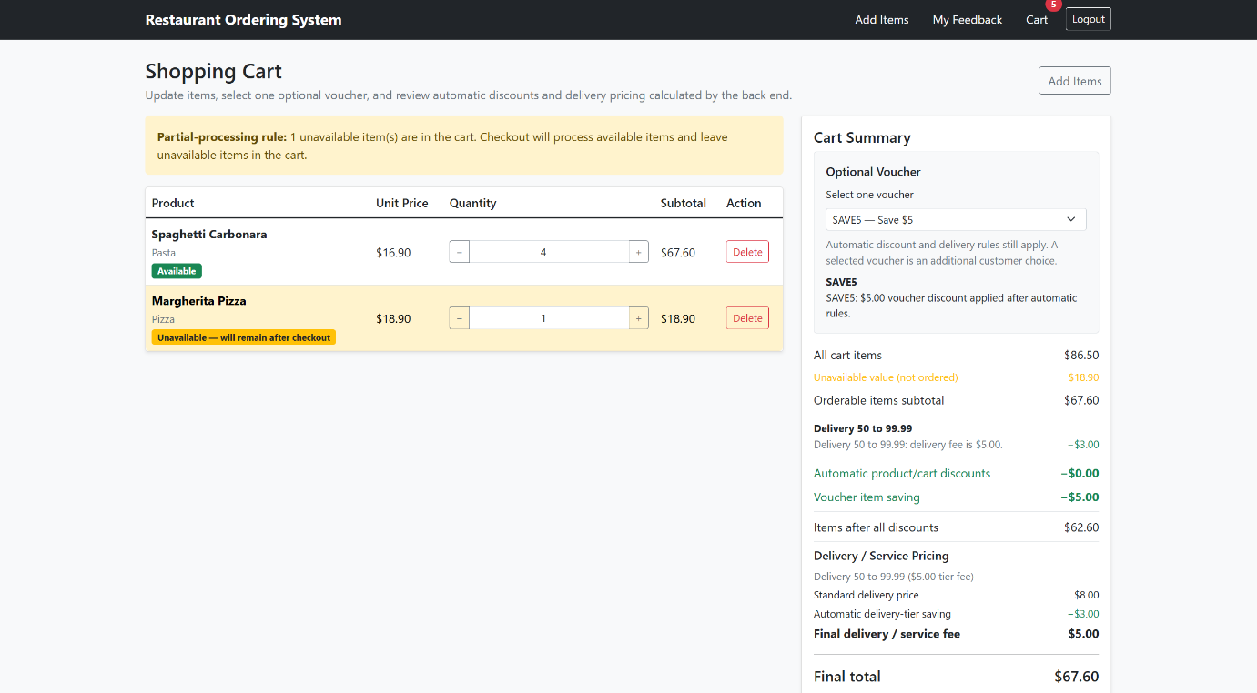
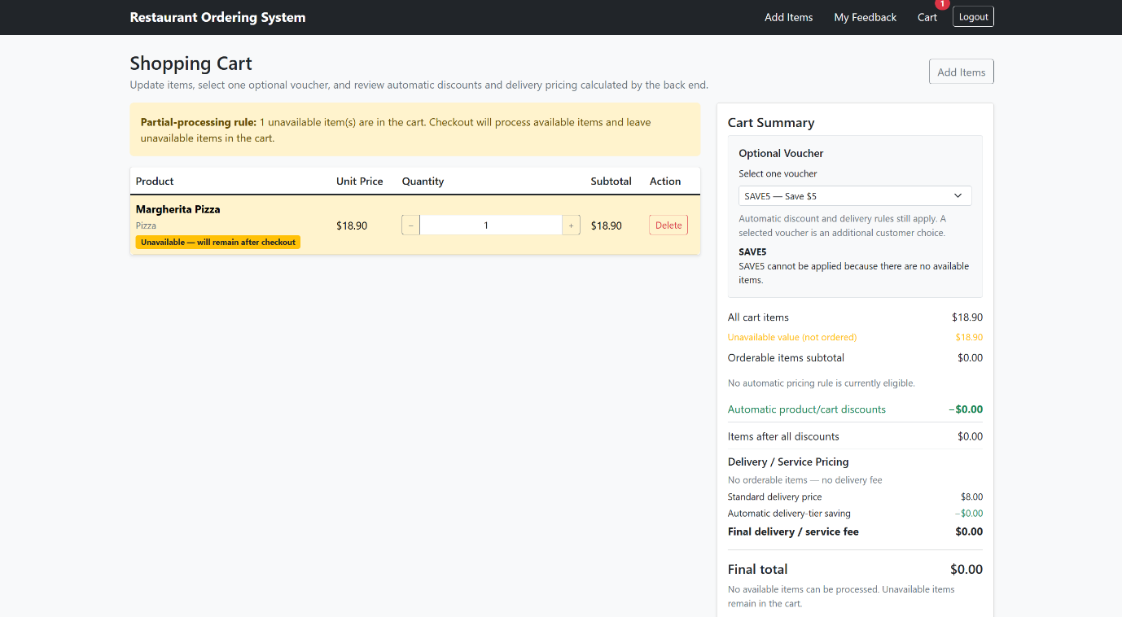

5. Manufacturer Queries and Indexing
The separate manufacturer database was restored without being connected to the application. Six queries were proposed against its manufacturer table, and six matching indexes were created. This follows the indexing practical’s method: first observe the actual plan with EXPLAIN ANALYSE, create an index that matches the predicate/expression/selected columns, then rerun the same query and record the plan and execution time.
Query | Purpose and index | Before time | After time | Result
Q1 | Case-insensitive support-email lookup; function index LOWER(support_email). | 146.236 ms | 0.080 ms | Bitmap index scan; 99.95% lower.
Q2 | Operating manufacturers by origin/category; composite (origin, product_category, is_operational). | 50.823 ms | 44.842 ms | Bitmap index scan; 11.77% lower.
Q3 | Category and founded-date range; composite (product_category, founded_since). | 47.819 ms | 26.441 ms | Bitmap index scan; 44.70% lower.
Q4 | Origin plus employee-count range; composite (origin, employee_count). | 43.875 ms | 24.875 ms | Bitmap index scan; 43.30% lower.
Q5 | Founded year; function index EXTRACT(YEAR FROM founded_since). | 76.168 ms | 22.274 ms | Bitmap index scan; 70.76% lower.
Q6 | Employee aggregate for category/operational status; covering (product_category, is_operational, employee_count). | 50.403 ms | 5.632 ms | Index-only scan; 88.83% lower.

The before-and-after output was collected on the supplied manufacturer backup containing 818,244 rows. The marker should see the exact SQL, raw plan outputs, and concise reasoning in the repository. Performance results can differ on another machine; the report therefore states the database and evidence files used rather than claiming a universal runtime.

